**INTERCONTINENTAL CHICAGO MAGNIFICENT MILE**

505 North Michigan Avenue, Chicago, IL 60611

Program Guide

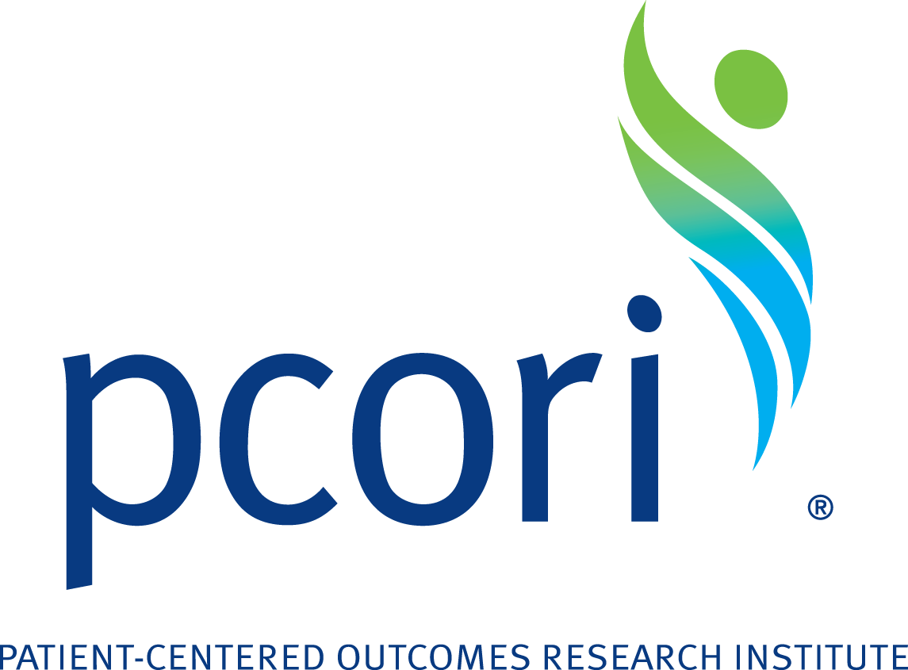



April 10–11, 2017

**Getting to Know PCORI:   
From Application to Closeout**

This page intentionally left blank.

**About PCORI**

The Patient-Centered Outcomes Research Institute (PCORI) is committed to transparency and a rigorous stakeholder-driven process that emphasizes patient engagement. PCORI uses a variety of forums and public comment periods to obtain public input to enhance its work.

**Our Mission**

PCORI helps people make informed healthcare decisions and improves healthcare delivery and outcomes by producing and promoting high-integrity, evidence-based information that comes from research guided by patients, caregivers, and the broader healthcare community.

**Our History**

The Patient Protection and Affordable Care Act of 2010 authorized PCORI as a nonprofit, nongovernmental organization. PCORI’s purpose, as defined by the law, is to help patients, clinicians, purchasers, and policy makers make better-informed health decisions by “advancing the quality and relevance of evidence about how to prevent, diagnose, treat, monitor, and manage diseases, disorders, and other health conditions.”

The statutory language defining PCORI is broad and authorizes research that will support a strong patient-centered orientation, inform better choices among alternative treatment and prevention strategies, and direct attention to individual and system differences that might influence strategies and outcomes. PCORI was designed to produce knowledge through the analysis and synthesis of existing research and the support of new research.

**Patient-Centered Outcomes Research Institute**

**1828 L St. NW, Suite 900**

**Washington, DC 20036**

**Phone: 202-827-7700**

**Fax: 202-355-9558**

**Email:** [**info@pcori.org**](mailto:info@pcori.org)

**Follow us on Twitter: @PCORI**

Table of Contents

Welcome! 1

Detailed Workshop Agenda – Intercontinental Chicago Magnificent Mile 2

Hotel Layout 5

Directions to the Hotel 7

Speaker Biographies 8

Appendix A: PCORI Acronym List 13

Notes 14

# Welcome!

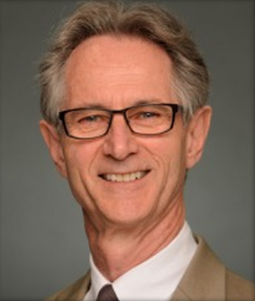Welcome to Chicago and our *Getting to Know PCORI: From Application to Closeout* workshop. Our goal is to provide you with the tools and strategies to develop a winning PCORI application. This interactive workshop—led by our staff—will offer an overview of PCORI and the work we do, including:

* National Priorities for Research and Methodology Standards
* Our funding announcements, application, and merit review processes
* Our patient and stakeholder engagement requirements
* Our post-award administrative requirements

Our goal is to help you navigate the many funding opportunities we offer. These include our broad funding announcements, which yield a diverse set of proposals and represent the research community’s most creative thinking in areas of high interest to patients and other healthcare stakeholders, as well as our targeted funding announcements, which seek research proposals on specific high-priority questions identified through our topic generation and research prioritization process. All of these opportunities serve as valuable paths for supporting studies aimed at improving health care and outcomes that matter to patients, as well as supporting young scientists doing important work.

Our Pragmatic Clinical Studies initiative is our process for funding pragmatic clinical trials, large simple trials, and large-scale observational studies comparing two or more options for addressing a major health problem. We announced the first round of awards in February 2015 and have since expanded this program.

We are especially glad you are participating in this workshop because, as a learning healthcare organization, we strive to improve the way we do our work, and we want to keep you abreast of our evolving research agenda and focus. For example, we continue to issue broad funding announcements inviting smaller projects on a range of topics, but that the amount of funding dedicated to these projects has tapered. At the same time, we continue increasing the number of larger, more targeted research projects we support and the proportion and amounts of funding dedicated to them. We see this natural evolution of our research focus as providing even more opportunities to build or enhance partnerships with key stakeholder groups to ensure that the studies will have the greatest impact possible.

We hope you will not only enjoy, but also learn from our speakers and session presenters and your conversations with your fellow attendees. You will have opportunities to meet face-to-face with our staff, ask questions, and obtain resources. On hand to offer insight are leaders from our contracts, research, and engagement departments who will provide both programmatic and administrative intelligence to arm you with a blueprint to apply for and manage a PCORI contract.

And now, let’s learn and share with our community of colleagues.

Again, welcome to Chicago. Enjoy the workshop!

Joe V. Selby, MD, MPH  
Executive Director

# Detailed Workshop Agenda – Intercontinental Chicago Magnificent Mile

|  |
| --- |
| Monday, April 10, 2017 |

|  |  |
| --- | --- |
| 11:00 a.m.–6:00 p.m.  Avenue Ballroom Foyer | REGISTRATION |
|  | PRE-WORKSHOP SESSIONS |
| 1:00 p.m.–2:00 p.m.  Avenue Ballroom | Research in Real-World Settings: PCORI’s Model for Comparative Clinical Effectiveness Research (CER)  David Hickam, MD, MPH, Program Director, Science, Clinical Effectiveness and Decision Science Program  Layla Lavasani, PhD, MHS, Senior Program Officer, Clinical Effectiveness and Decision Science Program  During this session, we will review PCORI’s model of CER and how to frame research questions using this model. We will further address issues of study design and how to evaluate the trade-offs among alternative designs, and introduce PCORI’s Methodology Standards and how they are used to improve the quality of clinical research. |
| 2:15 p.m.—3:00 p.m. | What PCORI Means By Engagement  *Lia Hotchkiss, Director, Eugene Washington PCORI Engagement Awards Program*  During this session, we will discuss the importance of patient and other stakeholder engagement in research and how this supports PCORI’s mission of patient-centered research. We will also review how PCORI evaluates engagement practices and provide an overview of the Engagement Rubric, a tool created to help research partners and PCORI ensure the meaningful engagement of patients and other stakeholders within PCORI-funded research teams. |
| 2:00 p.m.–5:00 p.m.  *St. Clair* | PCORnet Private Group Meeting |
| 6:00 p.m.–8:00 p.m.  King Arthur Court | NETWORKING RECEPTION and DINNER |

| **Tuesday, April 11, 2017** | |
| --- | --- |
| 7:00 a.m.–5:00 p.m.  Avenue Ballroom Foyer | REGISTRATION |
| 7:30 a.m.–8:45 a.m.  King Arthur Court | BREAKFAST |
| 9:00 a.m.–10:00 a.m.  Avenue Ballroom | Welcome and Overview of PCORI  Scott Solomon, MBA, MSE, Director, Contracts Management and Administration  During this session, we will provide an overview of PCORI—its mission, vision, and purpose. This session will describe the differences between broad and targeted funding announcements and related PCORI funding elements. |
| 10:00 a.m.–11:00 a.m. | Overview of PCORI Funding Announcements (PFAs), Priority Topics for Research, and Methodology Standards  David Hickam, MD, MPH, Program Director, Science, Clinical Effectiveness and Decision Science Program  Layla Lavasani, PhD, MHS, Senior Program Officer, Clinical Effectiveness and Decision Science Program  During this session, we will discuss PCORI’s models of comparative clinical effectiveness research and how PCORI has defined its funding programs. This session will also review PCORI’s process for identifying priority clinical topics, describe the ways PCORI is promoting best practices in research, and identify successful strategies for receiving future PCORI funding. |
| 11:00 a.m.–11:15 a.m. | BREAK |
| 11:15 a.m.–12:00 p.m. | PCORI’s Clinical Research Network (PCORnet) – PCORI’s “Front Door” Initiative  Maryan Zirkle, MD, MS, MA, Program Officer, Science, Research Infrastructure Program  During this session, we will provide an overview of PCORnet and showcase the PCORnet Front Door initiative, which guides interested parties in accessing PCORnet resources. Potential research partners include investigators, patient groups, healthcare organizations, clinicians or clinician groups, government and industry scientists, and funders. PCORnet resources include data network queries, requests for network collaborators, and requests for conducting a PCORnet study. |
| 12:00 p.m.–1:15 p.m.  King Arthur Court | NETWORKING AND LUNCH |
| 1:15 p.m.–2:00 p.m. | Overview of PCORI Engagement Funding Opportunities  Lia Hotchkiss, Director, Eugene Washington PCORI Engagement Awards Program  PCORI has two sources for funding under the engagement umbrella – The Eugene Washington Engagement Awards and the Pipeline to Proposal Awards Initiative. We’ll describe both programs in detail, the application process, and highlight example projects. |
| 2:00 p.m.–3:15 p.m. | PCORI’s Application Submission Process, Preparing a Budget, and Related Programmatic and Administrative Considerations  Iris Giggetts, MSW, CRA, Administrator, Contracts Operations, Contracts Management and Administration  Critical to the successful submission of an application, this session will provide a detailed overview of PCORI’s application and Letter of Intent (LOI) process, including programmatic requirements (completing required templates such as the Research Plan) and administrative requirements (formatting and submission guidelines). |
| 3:15 p.m.–3:30 p.m. | BREAK |
| 3:30 p.m.–4:15 p.m. | PCORI Merit Review Demystified  Mari Kimura, MS, PhD, Merit Review Officer  What happens to your application after you submit? In this session, we will walk through PCORI’s unique merit review process and share tips for succeeding in merit review. There will be time for open discussion. |
| 4:15 p.m.–4:45 p.m. | Contract Activation, Active Portfolio Management, and Financial Compliance  Scott Solomon, MBA, MSE, Director, Contracts Management and Administration  Once PCORI awards funding, an applicant is issued a contract with PCORI. During this session, we will discuss PCORI’s five phases of requirements—award monitoring, budget review, reporting, active portfolio management and contract closeout. We will also discuss some common administrative issues that occur during contract activation and how to address them. |
| 4:45 p.m.–5:00 p.m. | Wrap-Up and Conclusion |

# Hotel Layout

**April 10**

* Registration (Outside Avenue Ballroom Foyer, 11:00 a.m.–6:00 p.m.)
* Pre-Workshop Sessions (Avenue Ballroom, 1:00 p.m.–5:00 p.m.)
* Reception and Dinner (King Arthur Court, 6:00 p.m.–8:00 p.m.)

**April 11**

* Breakfast and Lunch (King Arthur Court, Breakfast 7:30 a.m.–8:45 a.m.,   
  Lunch 12:00 p.m.–1:15 p.m.)
* General Sessions (Avenue Ballroom, 9:00 a.m.–12:00 p.m., 1:15 p.m.–5:00 p.m.)
* Registration (Outside Avenue Ballroom Foyer, 7:00 a.m.–5:00 p.m.)

## Lobby Level

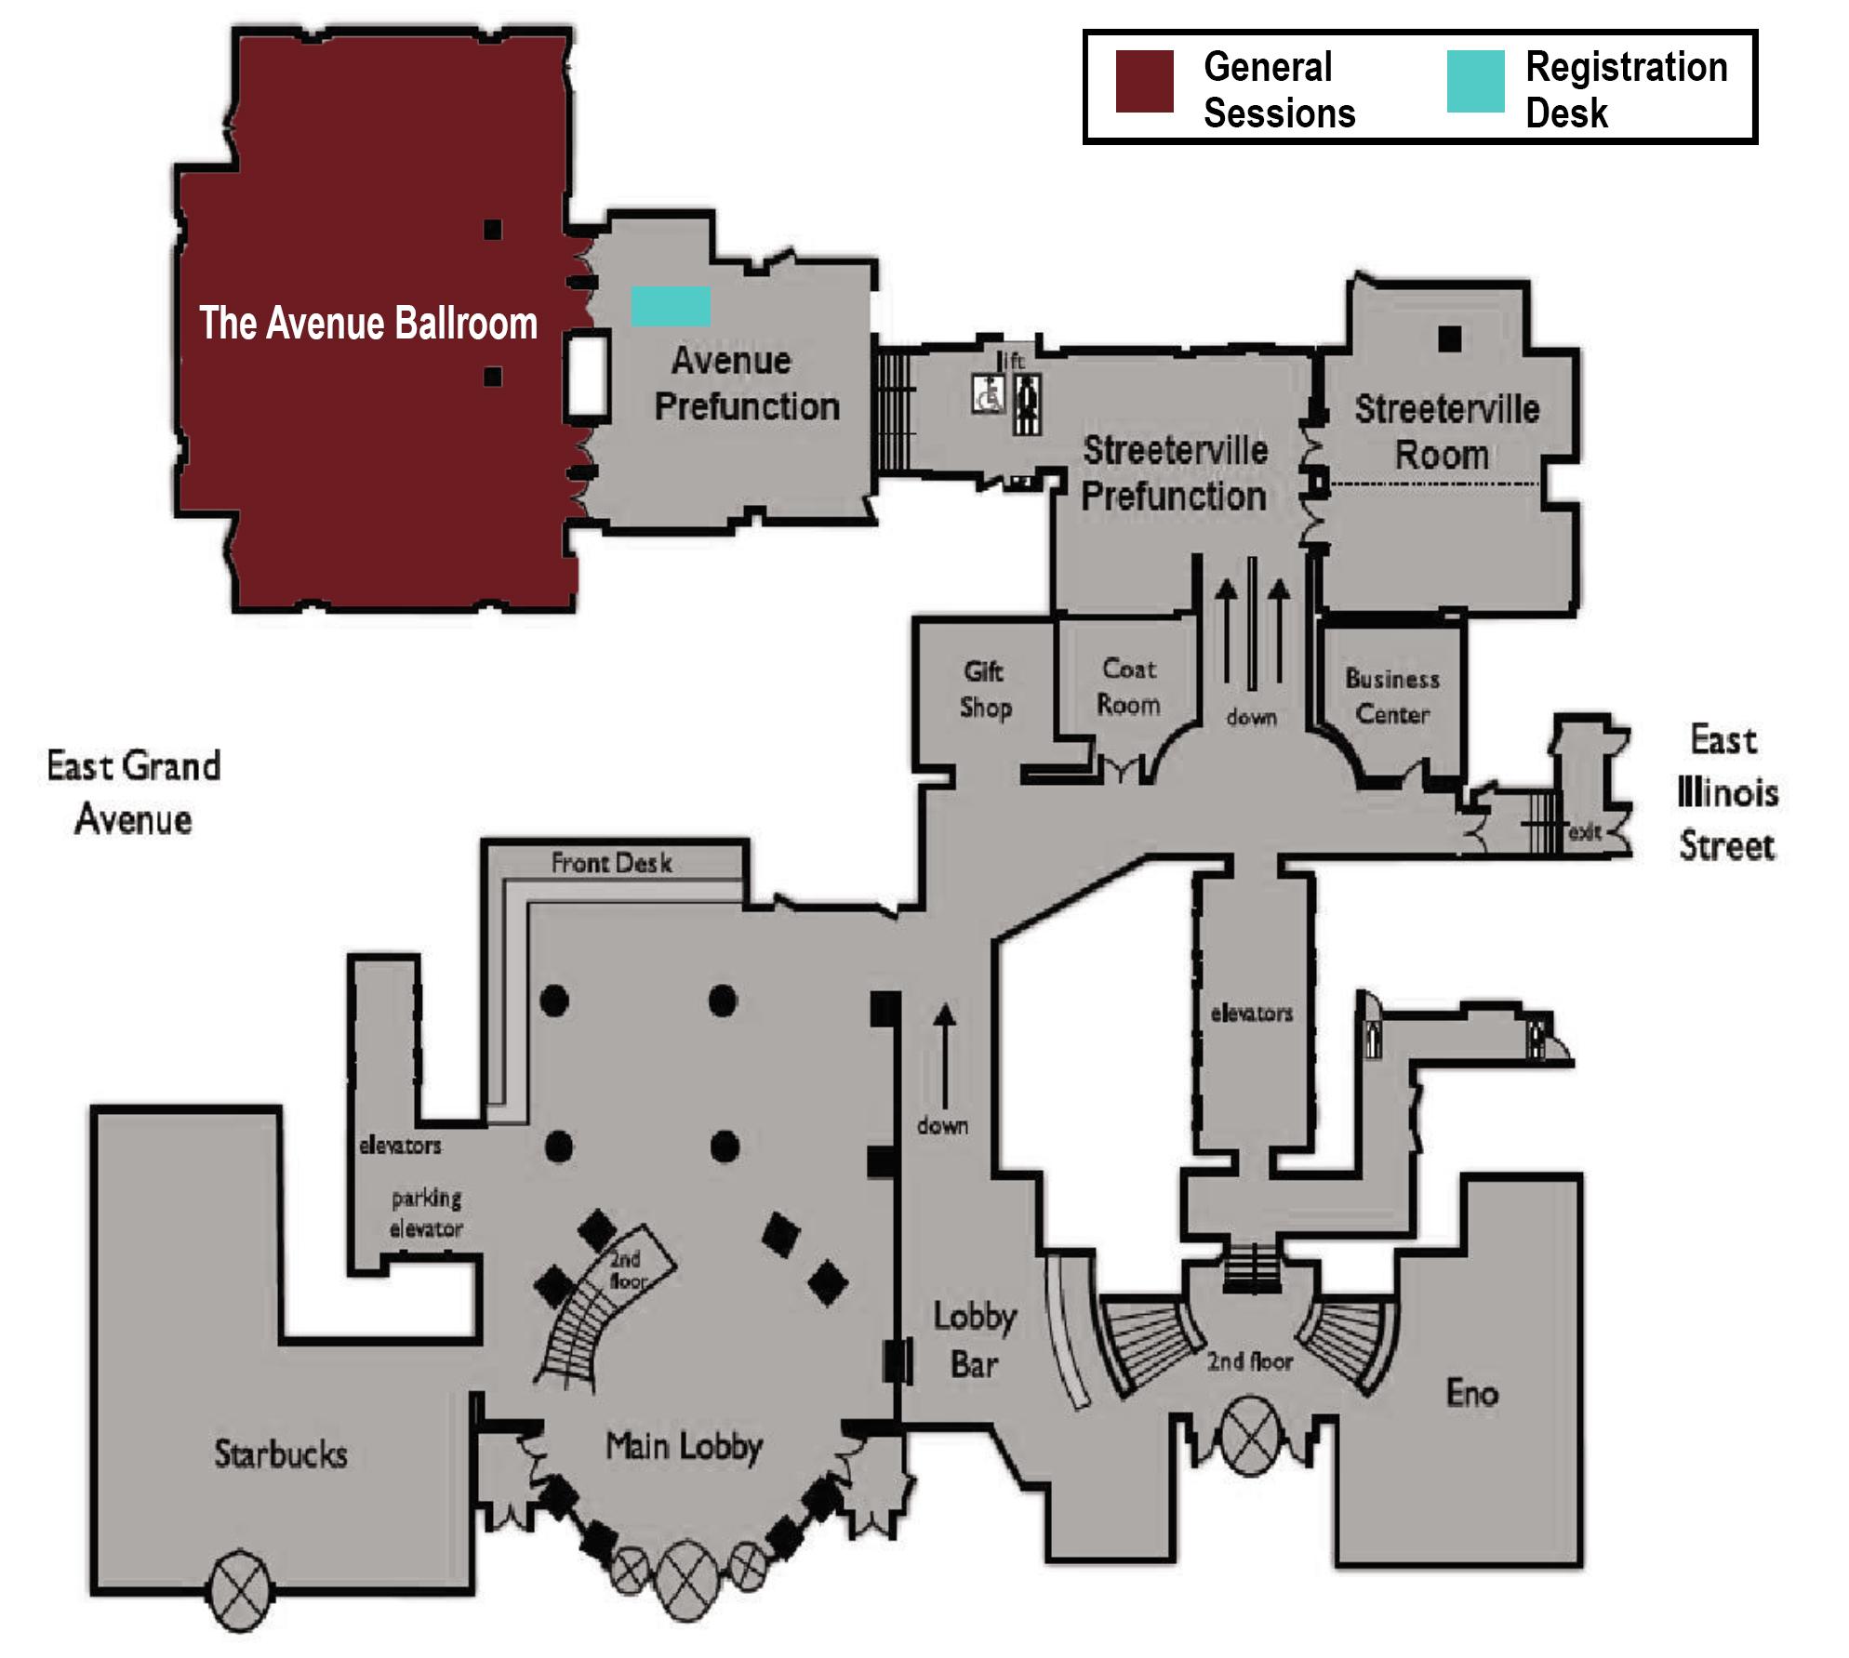

## Third Floor Level

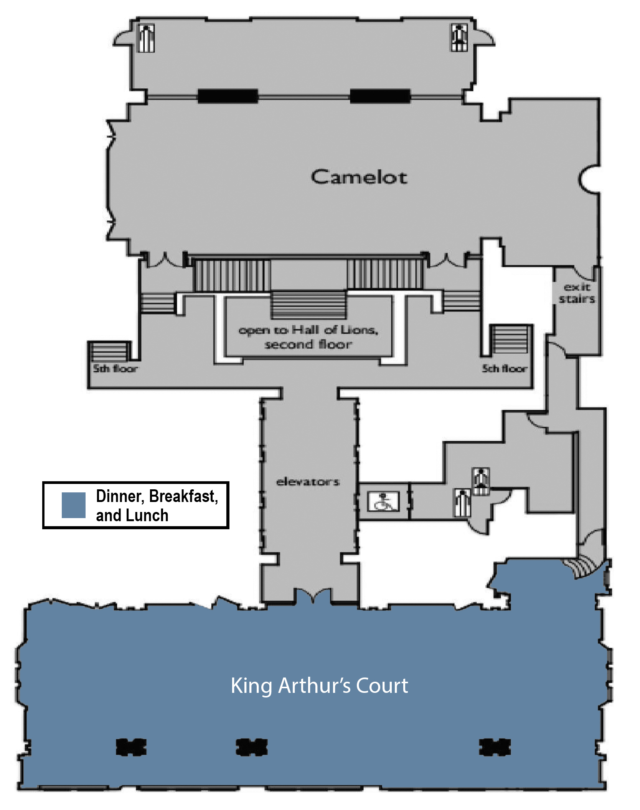

# Directions to the Hotel

**INTERCONTINENTAL CHICAGO MAGNIFICENT MILE**   
505 North Michigan Avenue   
Chicago, IL 60611   
Phone: (312) 944-4100

* Valet parking ($68 overnight fee)
* Shared airport shuttle rides & private car service available with rates starting at $27.94. Guests save an additional 10% off shuttle services when booking direct through Go Airport Express, our trusted transportation service.

## O'Hare International Airport to Hotel

* Start out going east on I-190 E/Kennedy Expy E.
* Stay straight to go onto I-90 E/Kennedy Expy E.
* Take the Ohio St E exit, EXIT 50B, toward 600 N.
* Stay straight to go onto W Ohio St.
* Turn right onto N Michigan Ave.
* N Michigan Ave is just past N Rush St
* Make a U-turn onto N Michigan Ave.
* 505 N Michigan Ave, Chicago, IL 60611-3801, 505 N Michigan Ave is on the right.

## Chicago Midway International Airport to Hotel

* Start out going south on S Cicero Ave/IL-50.
* Take the ramp toward Terminal/Garage.
* Keep left to take the ramp toward Arrivals.
* Turn slight left onto W Airport Dr.
* Take W Airport Dr. toward Airport Exit/I-55/Stevenson Expy.
* Turn slight right onto S Cicero Ave/IL-50.
* Merge onto I-55 N/Adlai E Stevenson Expy N toward Chicago.
* Merge onto I-90 W/I-94 W via EXIT 292A toward Wisconsin.
* Take the Lake St exit, EXIT 51A, toward 200 North.
* Turn right onto W Lake St.
* Turn left onto W Wacker Dr.
* W Wacker Dr. is 0.1 miles past N Canal St.
* Turn left onto N Michigan Ave.
* N Michigan Ave is 0.1 miles past N Wabash Ave.
* 505 N Michigan Ave, Chicago, IL 60611-3801, 505 N Michigan Ave is on the right.

# Speaker Biographies

## Iris Giggetts, MSW, CRA

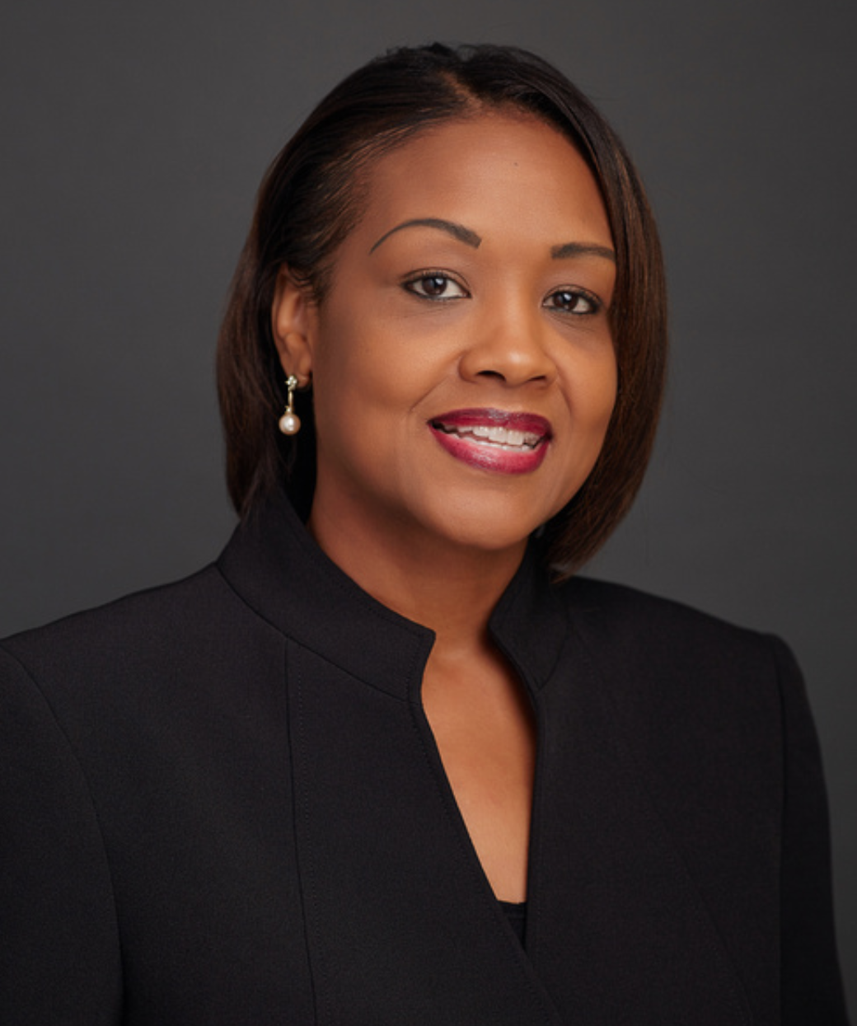Administrator, Contracts Operations, Contracts Management and Administration

Iris Giggetts is a Contracts Operations Administrator for the Contracts Management and Administration (CMA) team at PCORI. In this role, she provides project management and research administration support to applicants, reviewers, and awardees applying to Pragmatic Clinical Studies funding announcements. She also trains CMA staff on the PCORI pre-award lifecycle. She previously was a contracts associate for pre-award administration at PCORI.

Before joining PCORI, Giggetts was a grants administrator at Virginia Commonwealth University’s School of Medicine, where she assisted faculty members with pre- and post-award management. She was also the fiscal administrator and effort coordinator for the department. Giggetts also served as executive director of the Rappahannock Teen Awareness Program, where she wrote and managed grants for the organization.

Giggetts received a BS in Social Work and an MSW with a concentration in policy, planning and administration from Virginia Commonwealth University. She is also a Certified Research Administrator.

## David Hickam, MD, MPH

Program Director, Science, Clinical Effectiveness and Decision Science Program

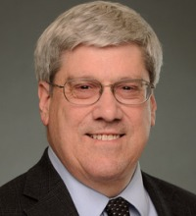Dr. David Hickam is responsible for developing PCORI’s research program that evaluates comparisons among alternative clinical strategies in a broad range of clinical domains. He also provides staff support to the PCORI Methodology Committee.

Dr. Hickam is a specialist in internal medicine and has 30 years’ experience as a health services researcher. His past research has focused on strategies for improving healthcare outcomes among adults with chronic diseases. Dr. Hickam previously served as a professor in the Department of Medicine at Oregon Health and Science University (OHSU). He also held a joint faculty appointment in OHSU’s Department of Medical Informatics and Epidemiology. In addition, he served as a Senior Investigator in OHSU’s Oregon Evidence-based Practice Center and as Co-Director of the Health Services Research and Development Program at the U.S. Department of Veterans Affairs Portland Medical Center. Dr. Hickam has expertise in a broad range of quantitative and qualitative research methodologies.

Dr. Hickam received his BA from Stanford University, his MD from the University of California – San Francisco, and his MPH from the University of California – Berkeley.

## Lia Hotchkiss, MPH

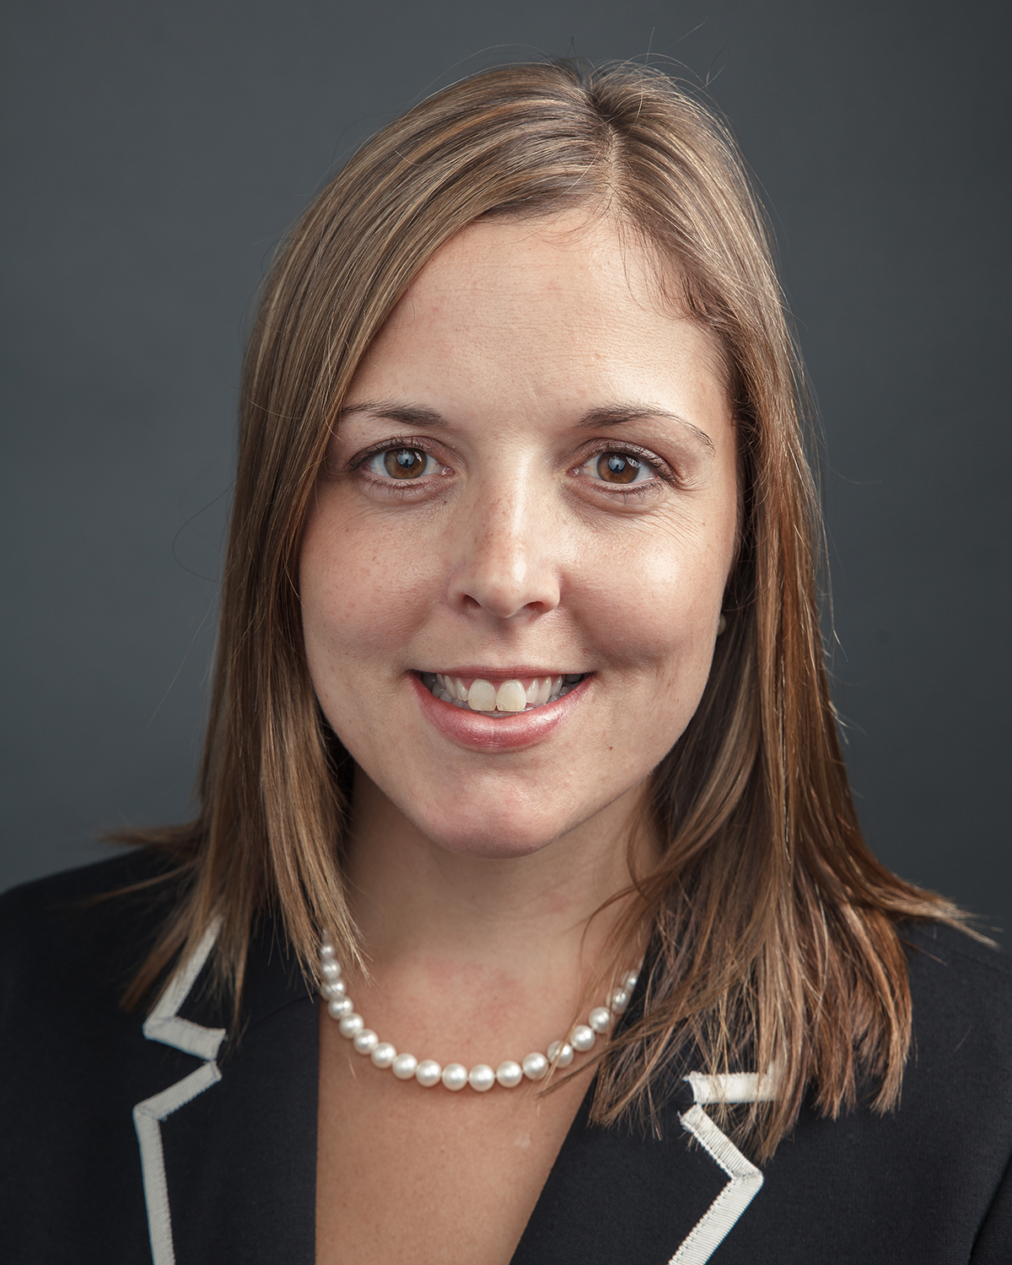Director, Eugene Washington PCORI Engagement Awards Program

Lia Hotchkiss is Director of the Eugene Washington PCORI Engagement Award Program at PCORI. She sets the strategic direction and oversees the implementation of the program, which aims to support more active integration of patient, research, and other stakeholder communities in the patient-centered outcomes research process.

Before joining PCORI, Hotchkiss was at the UPMC Health Plan, where she initiated, planned, and executed projects and programs for the consumer innovation department. She also served as director of the Agency for HealthCare Research and Quality’s (AHRQ) Comparative Effectiveness Research Portfolio. In this role, she worked with staff across AHRQ to develop research projects, wrote requests for applications and program announcements, and established portfolio metrics.

Hotchkiss received a BA in linguistics and biology from the University of Rochester, and an MPH in epidemiology from the University at Albany School of Public Health. She is also a certified project management professional and Six Sigma Green Belt.

## Mari Kimura, MS, PhD

Merit Review Officer

Dr. Mari Kimura is a Merit Review Officer, Research Integration and Evaluation at PCORI. She is responsible for organizing and managing the comprehensive scientific and technical review of applications submitted for PCORI funding, ensuring the integrity of the merit review process, and providing technical assistance to PCORI’s standing panels and other external reviewers.

Before joining PCORI, Kimura served as a science and technology policy Fellow with the American Association for the Advancement of Science at the U.S. Department of State and National Science Foundation. Her experience includes managing an international program on chemical safety and security, helping launch a program to digitize biological research collections, building partnerships in the private sector, conducting basic research, and teaching undergraduates. Her research focused on understanding the dynamics of disease in nature using molecular genetic tools.

Kimura received a BA in English from Columbia University, a MS in biology from San Francisco State University, and a PhD in ecology and evolutionary biology from Cornell University.

## Layla Lavasani, PhD, MHS

Senior Program Officer, Clinical Effectiveness and Decision Science Program

****Dr. Layla Lavasani is a Senior Program Officer for the Clinical Effectiveness and Decision Science program at PCORI. In this role, she oversees a number of large-scale clinical trials focused on chronic pain, and manages a diverse comparative effectiveness research portfolio. She also supports the development of PCORI funding announcements.

Before PCORI, Lavasani worked for Deloitte Consulting LLP, where she supported the federal health practice as a public health specialist on the translational medicine team. She provided subject matter expertise to Deloitte’s Strategy Service Line in a number of areas, including patient-centered outcomes research, comparative effectiveness research, maternal/child health, and global health.

Lavasani has also worked and collaborated with academic institutions, international nongovernmental organizations, and government agencies on research programs that seek to improve access and utilization of health services among vulnerable populations. Her areas of technical expertise include survey design, monitoring and evaluation, and complex econometric/analytical methods. Lavasani has led the design and implementation of health assessments in Afghanistan, and has provided technical assistance to health programs in Africa and Asia.

Lavasani earned a BA in political science from Saint Louis University, an MHS in international health with a concentration in health systems from the Johns Hopkins Bloomberg School of Public Health, and a PhD in maternal and child health with a focus in health policy and management from the University of North Carolina at Chapel Hill Gillings School of Global Public Health.

## Scott Solomon, MBA, MSE

Director, Contracts Management and Administration

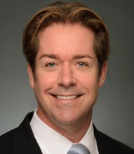Scott Solomon provides oversight of PCORI awards from pre-award through closeout. The functional areas within Contracts Management and Administration include pre-award, post-award, contracts communications, contracts systems (PCORI Online and Helpdesk), and contracts policy and planning. Solomon leads efforts to work with Science staff to develop PCORI Funding Announcements (PFAs) and conduct patient and stakeholder merit review events. He manages research desk reviews, audits, and site visits in collaboration with PCORI Science and Finance leadership, while also establishing award cost principles, policy and active portfolio management procedures. As the chief negotiator of PCORI contracts, Solomon collaborates with PCORI's General Counsel and Director of Finance to finalize the terms of all agreements and modifications. Finally, he supports the Board of Governors’ Finance and Administration Committee.

Previously, Solomon was PCORI’s Deputy Director of Finance in charge of procurement, financial compliance, and audit operations. As the Finance Department’s compliance officer, he developed and administered policies and procedures that support these functional areas. He also served as PCORI’s liaison to the Board of Governors’ for Conflict of Interest subcommittee activities.

Solomon has almost 25 years of experience managing grants and contracts in a variety of federal, nonprofit and higher education organizations. Most of his experience has been in the emergency response, law enforcement, and health education fields. He held positions of progressive leadership with an international labor union for emergency responders, and served as a senior advisor for numerous federal training centers, technology transfer and commercialization programs, and health and safety projects. Most recently, he served as the Director of Compliance and Audit—and then the Senior Director for Homeland Security—for a major research university in Washington, DC.

Solomon has an MBA in finance, an MS in engineering, and a post-graduate certificate in executive leadership from West Virginia University and The George Washington University.

## Maryan Zirkle, MD, MS, MA

Program Officer, Research Infrastructure Program

Dr. Maryan Zirkle is a Program Officer on the Research Infrastructure team at PCORI. She is responsible for providing intellectual and organizational support for the development and regulation of PCORI’s National Patient-Centered Clinical Data Research Network (PCORnet). She manages several large initiatives within PCORnet, including but not limited to the Clinical Data Research Networks (CDRNs), the Obesity Demonstration Studies, and both of the newly awarded Health Systems and Health Plans Initiatives.

Before joining PCORI, she worked as a Program Manager and Research Health Science Specialist at the U.S. Department of Veterans Affairs (VA). She gained considerable experience in poly-trauma, post-traumatic stress disorder, and medical informatics research at VA medical centers in Tampa, Florida, and Portland, Oregon. She also completed a three-year advanced fellowship in clinical informatics at the VA in Portland, Oregon.

Dr. Zirkle received two BAs from the University of Florida, a MA in rehabilitative and mental health counseling from the University of South Florida, a MS in biomedical and clinical informatics from Oregon Health and Science University, and a MD from Spartan Health Sciences University.

# Appendix A: PCORI Acronym List

|  |  |
| --- | --- |
| Acronym | Meaning |
| AO | Administrative Official |
| BoG | Board of Governors |
| CAN | Contract Award Notification |
| CEA | Cost-Effectiveness Analysis |
| CER | Comparative Clinical Effectiveness Research |
| CMA | Contracts Management and Administration |
| COI | Conflict of Interest |
| EFT | Electronic Funds Transfer |
| GAO | Government Accountability Office |
| IRB | Institutional Review Board |
| LOI | Letter of Intent |
| NIH | National Institutes of Health |
| PDF | Portable Document Format (Adobe) |
| PFA | PCORI Funding Announcement |
| PI | Principal Investigator |
| PIR | PCORI Information Request |

# Notes

|  |
| --- |
|  |
|  |
|  |
|  |
|  |
|  |
|  |
|  |
|  |
|  |
|  |
|  |
|  |

# Notes

|  |
| --- |
|  |
|  |
|  |
|  |
|  |
|  |
|  |
|  |
|  |
|  |
|  |
|  |
|  |

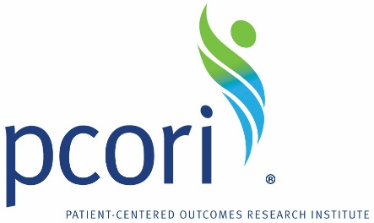

Patient-Centered Outcomes Research Institute

1828 L St. NW, Suite 900

Washington, DC 20036

Phone: 202-827-7700

Fax: 202-355-9558

Email: info@pcori.org

Follow us on Twitter: @PCORI